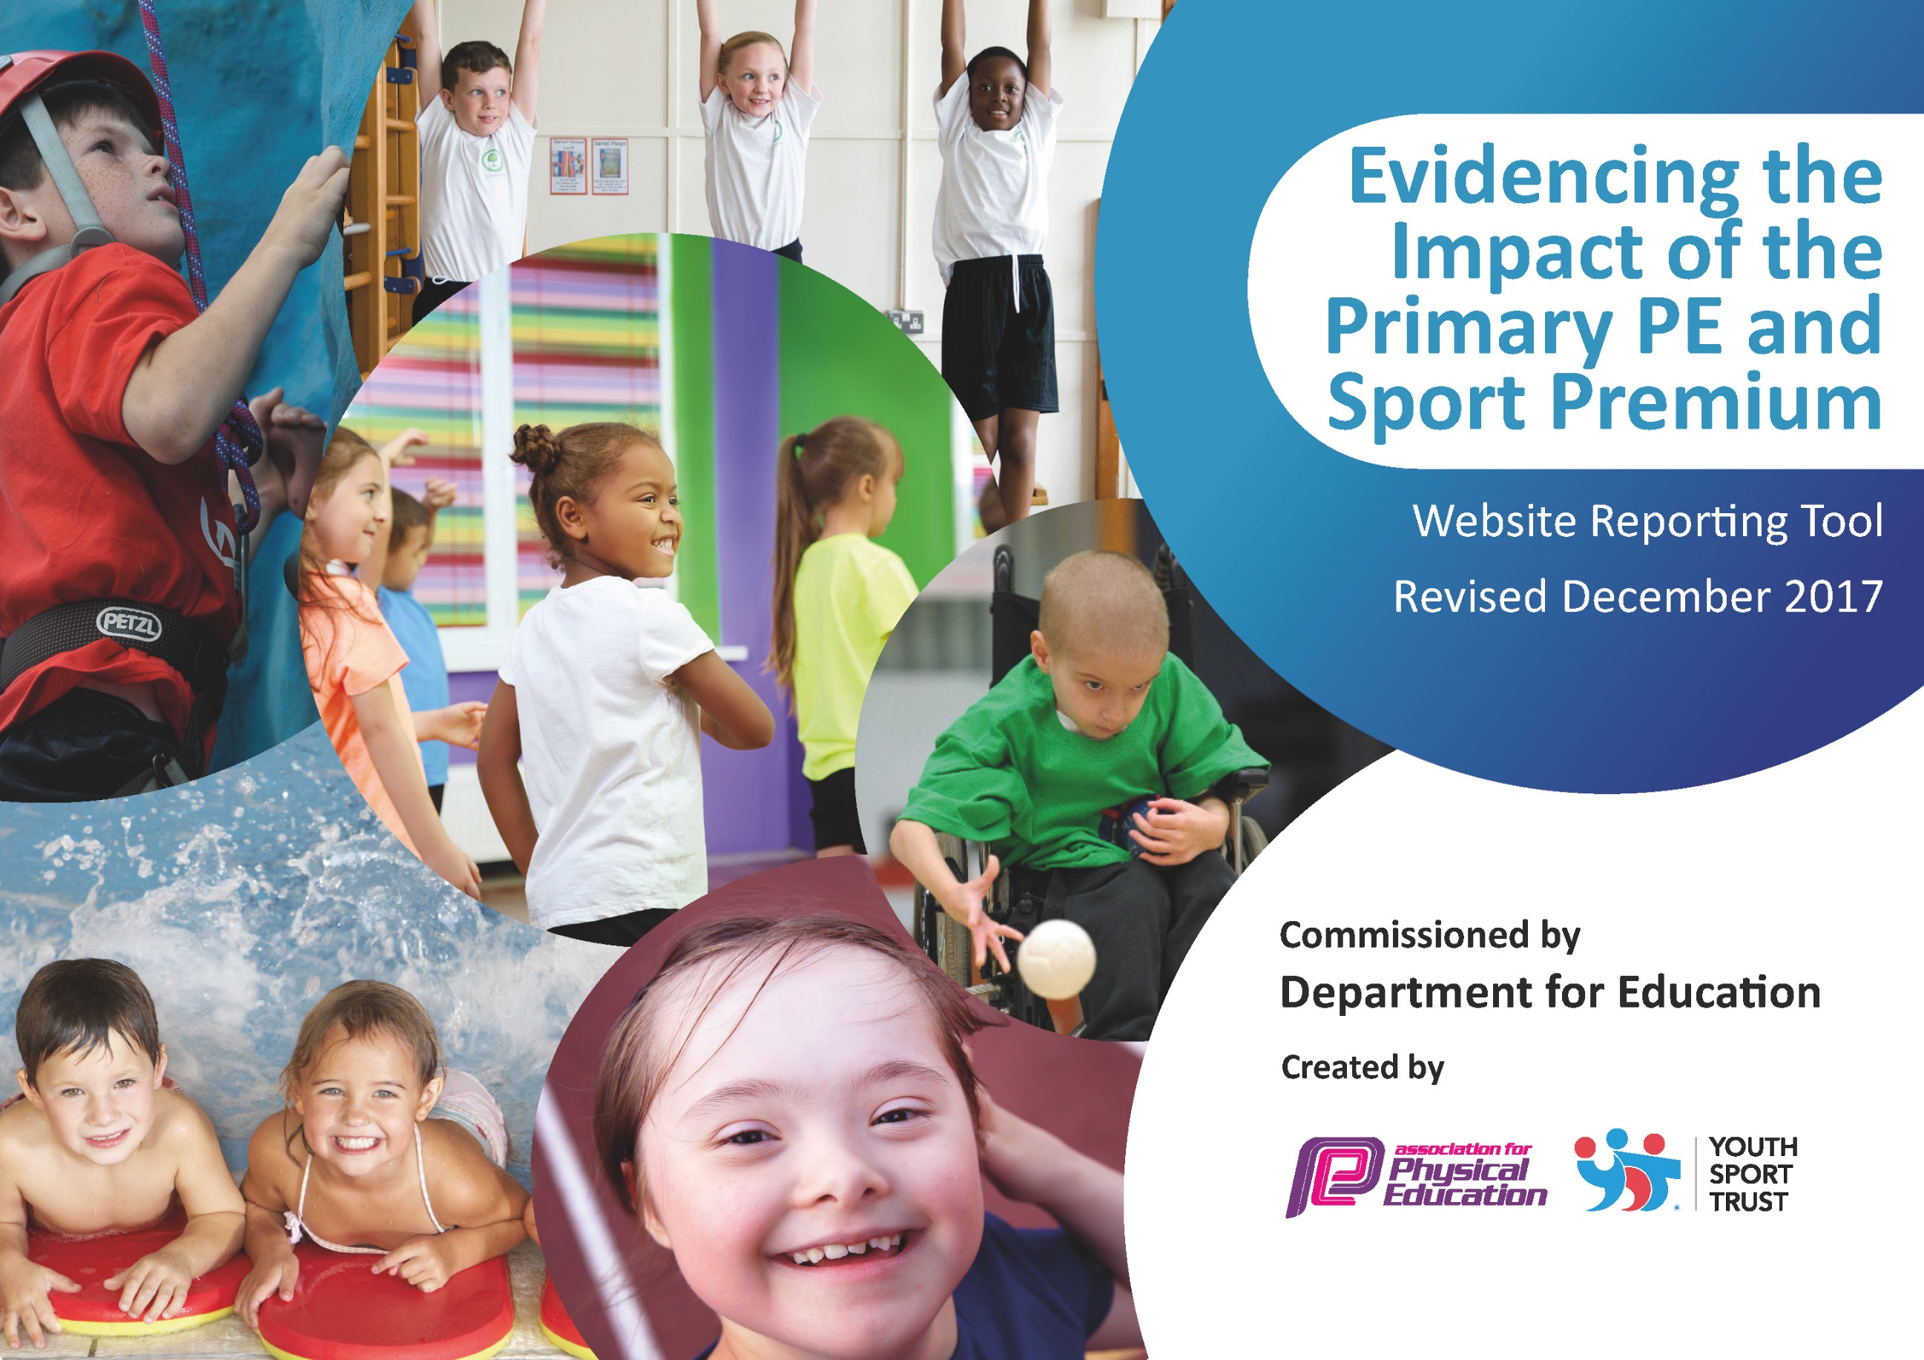

Schools must use the funding to make additional and sustainable improvements to the quality of PE and sport they offer. This means that you should use the Primary PE and Sport Premium to:

- develop or add to the PE and sport activities that your school already offers
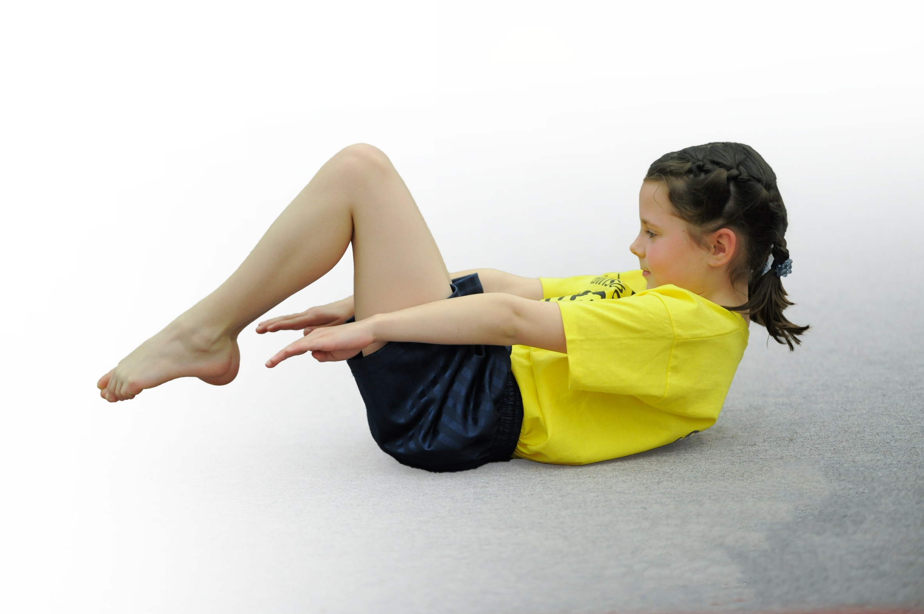
- build capacity and capability within the school to ensure that improvements made now will benefit pupils joining the school in future years

Please visit gov.uk for the revised DfE guidance including the 5 key indicators across which schools should demonstrate an improvement. This document will help you to review your provision and to report your spend. DfE encourages schools to use this template as an effective way of meeting the reporting requirements of the Primary PE and Sport Premium.

We recommend you start by reflecting on the impact of current provision and reviewing the previous spend.
Under the Ofsted Schools Inspection Framework, inspectors will assess how effectively leaders use
the Primary PE and Sport Premium and measure its impact on outcomes for pupils, and how effectively governors hold them to account
for this.

Schools are required to publish details of how they spend this funding as well as on the impact it has on pupils’ PE
and sport participation and attainment.
We recommend regularly updating the table and
publishing it on your website as evidence
of your ongoing review into how you are using the money
to secure maximum, sustainable impact. To see an example of how to complete the table please click HERE.

Askern Spa Junior School – Impact Report for the Primary PE and Sport Premium September 2018

Key achievements to date: | Areas for further improvement and baseline evidence of need:
- Swimming provision in Year 5  - Involvement in family of school’s competitions  - After School Club and Lunchtime Clubs  - Staff CPD through specialist provider and team teaching  - Staff Planning with support from ‘minikicks’ resources  - PE Leader attends PE network forum  - Assessment procedures in place and utilized by all staff (OTrack and ‘minikicks’)  - Transition work through sporting activities with secondary practitioners | - Daily Mile embedded within the school day  - Improved playground activities  - Improved extra-curricular offer  - Curriculum map to be improved to provide a range of broad and balanced activities  - Staff audit on PE skills  - PE Kit policy developed  - Participation in charity related sports activities (Campsmount support)

Meeting national curriculum requirements for swimming and water safety | Please complete all of the below*:
What percentage of your current Year 6 cohort swim competently, confidently and proficiently over a distance of at least 25 metres? | % to be reported in April 2019
What percentage of your current Year 6 cohort use a range of strokes effectively [for example, front crawl, backstroke and breaststroke]? | % to be reported in April 2019
What percentage of your current Year 6 cohort perform safe self-rescue in different water-based situations? | % to be reported in April 2019
Schools can choose to use the Primary PE and Sport Premium to provide additional provision for swimming but this must be for activity over and above the national curriculum requirements. Have you used it in this way? | Yes/No
*Schools may wish to provide this information in April, just before the publication deadline.

Action Plan and Budget Tracking
Capture your intended annual spend against the 5 key indicators. Clarify the success criteria and evidence of impact that you intend to measure to evaluate for students today and for the future.

Academic Year: 2018/19 | Total fund allocated: £19,182 | Date Updated: October 2018
Key indicator 1: The engagement of all pupils in regular physical activity – Chief Medical Officer guidelines recommend that primary school children undertake at least 30 minutes of physical activity a day in school |  |  |  | Percentage of total allocation:
 |  |  |  | (£10,300) 53.7%
School focus with clarity on intended impact on pupils: | Actions to achieve: | Funding allocated: | Evidence and impact: | Sustainability and suggested next steps:
Daily mile embedded into the school day to improve stamina and pupils’ concentration | Whole school to walk/run for approx. 15 mins per day | Posters, lap counters, markings £100 | Improved cardiovascular fitness of pupils, increased focus and attention in afternoon sessions | Progress from Daily Mile to alternative 15 min ‘blasts’ of exercise
Physical ‘wake up’ activities utilized across the school | Physical activity and practical approaches to classroom based activities across the day and all subjects | Training for staff £200 | Physical activity embedded into the school day and every classroom to improve moving regularly and increase attainment, attention and focus | Expected attainment across year groups after a year in place
Extra Curricular offer improved | Increased offer at lunchtime and after school to appeal to a wider range of pupils | Minikicks - £3000  Campsmount £2500  Other coaches £2000 | Intended increase of 20% taking part in extra curricular activities | Involvement of staff in additional activities out of school hours
Competitive schools tournaments | Increased numbers of pupils taking part in seasonal competitive sports through Family of schools links and in-school competitions | Transport costs and staff release  £2500 | Improved physical, mental and social skills. | Clubs embedded in offer within school to support competitions
Key indicator 2: The profile of PE and sport being raised across the school as a tool for whole school improvement |  |  |  | Percentage of total allocation:
 |  |  |  | (£1,735) 9%
School focus with clarity on intended impact on pupils: | Actions to achieve: | Funding allocated: | Evidence and impact: | Sustainability and suggested next steps:
Physical ‘wake up’ activities utilized across the school (see above)
Attendance at Pyramid Schools Competitions | Pupils provided with different experiences and opportunities to work as part of a team and compete against others, respect rules and other adults. | Team Bibs and Shirts £100  Buses and staff cover (see above) | Improved physical, mental and social skills. | Club links to competitions embedded in after school and lunchtime offer.
Sports Day  Community Day | School spirit and ethos shown through resilience and cooperation skills developed.  Opportunities to try new activities with family members and promote family fitness and enjoyment. | Sports day equipment £100  Transport £500 | Improved physical, mental and social skills.  Improved physical, mental and social skills.  Family engagement and embedding healthy lifestyles | Annual event  Annual event
Sports Reporters | Attendance at school events and competitions | Notebooks and pans, printing costs £50 | Sense of belonging, literacy developed across the curriculum | Attend every competition on a rota basis
Sports Leaders (Minikicks coaches) | Lead lunchtime and breaktime activities for younger pupils and support lunchtime supervisors | Minikicks coach to embed in Autumn term £985 (as part of package) | Sense of responsibility, organization and leadership skills.  Role models for younger students  Reduction in behavioural issues and boredom at non-curriculum times | Indoor and outdoor activities for leaders to organize in future.

Key indicator 3: Increased confidence, knowledge and skills of all staff in teaching PE and sport |  |  |  | Percentage of total allocation:
 |  |  |  | (£3,000) 15.6%
School focus with clarity on intended  impact on pupils: | Actions to achieve: | Funding  allocated: | Evidence and impact: | Sustainability and suggested  next steps:
Staff to team teach alongside sports specialists | Key staff to receive support for at least half a term of the academic year in an activity of weakness | £3,000 Minikicks coaches and coaches from Campsmount (see above) | Increased staff confidence in delivery  Improved engagement and participation | Roll out to other sport provision
Transition work to Y6 from sports specialist | Y6 staff to receive support in a range of secondary sports. Focus on engaging key Y6 pupils | Campsmount as part of package (see above) | Increased staff confidence in delivery  Improved engagement and participation | Y6 engagement ready for transition to secondary.
Key indicator 4: Broader experience of a range of sports and activities offered to all pupils |  |  |  | Percentage of total allocation:
 |  |  |  | (£4,147) 21.6%
School focus with clarity on intended  impact on pupils: | Actions to achieve: | Funding  allocated: | Evidence and impact: | Sustainability and suggested  next steps:
Additional clubs and coaching sessions (some linked to competitions) for:  - Rugby  - Basketball  - Dance  - Gymnastics  - Football | Engage targeted pupils in extra-curricular activity.  Introduce new sports and activities | Coaches from Minikicks & Campsmount as part of package (£3,947) | Pupil interest and engagement in new activities showing resilience and risk taking. | Sports embedded in curriculum map
Playground development | New resources and line markings introduced to designated playing zones. | £200 for resources | Experience new activities  Reduction in behavioural issues in non-structured times.
Key indicator 5: Increased participation in competitive sport |  |  |  | Percentage of total allocation:
 |  |  |  | Covered in other areas
School focus with clarity on intended  impact on pupils: | Actions to achieve: | Funding  allocated: | Evidence and impact: | Sustainability and suggested  next steps:
Competitive sport and sports days (see above) |  | See above

