
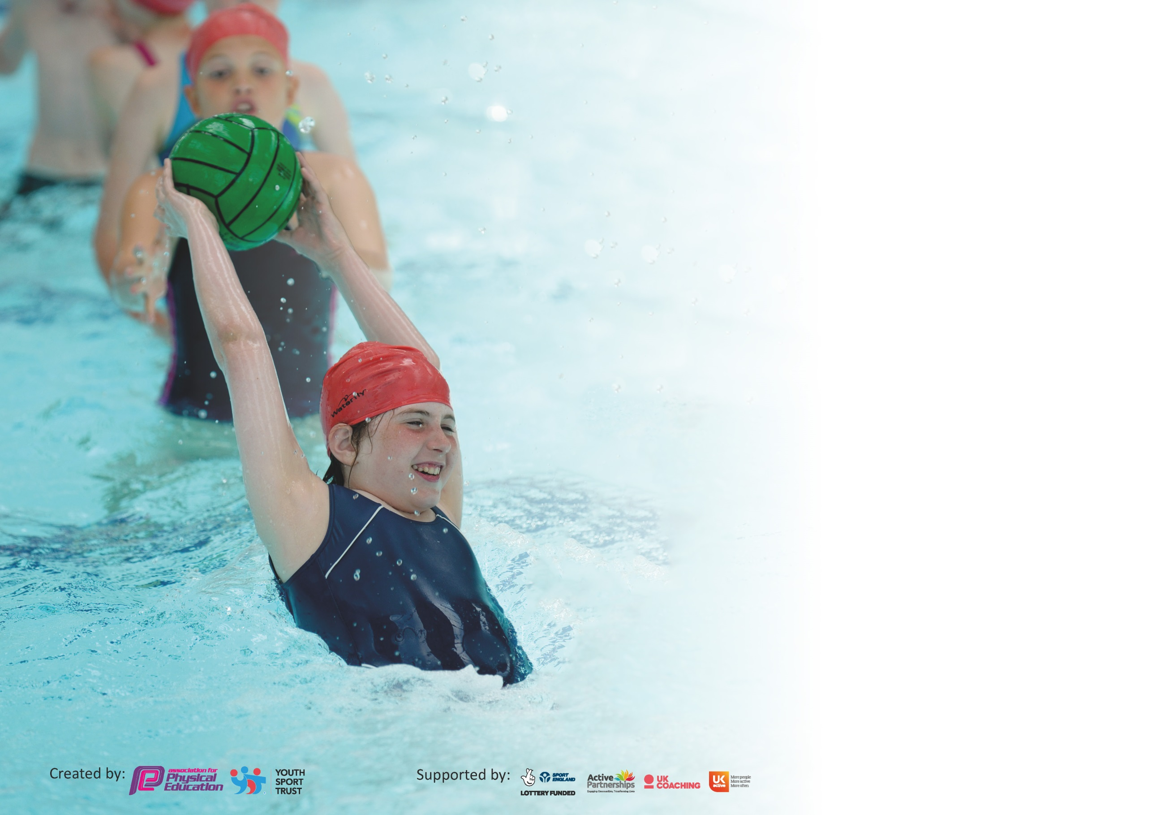

It is important that your grant is used effectively and based on school need. The Education Inspection Framework (Ofsted 2019 p64) makes clear there will be a focus on ‘whether leaders and those responsible for governors all understand their respective roles and perform these in a way that enhances the effectiveness of the school’.

Under the Quality of Education criteria (p41) inspectors consider the extent to which schools can articulate their curriculum (INTENT), construct their curriculum (IMPLEMENTATION) and demonstrate the outcomes which result (IMPACT).

To assist schools with common transferable language this template has been developed to utilise the same three headings which should make your plans easily transferable between working documents.

Schools must use the funding to make additional and sustainable improvements to the quality of Physical Education, School Sport and Physical Activity (PESSPA) they offer. This means that you should
use the Primary PE and Sport Premium to:

- Develop or add to the PESSPA activities that your school already offer
- Build capacity and capability within the school to ensure that improvements made now will benefit pupils joining the school in future years

Please visit gov.uk for the revised DfE guidance including the 5 key indicators across which schools should demonstrate an improvement. This document will help you to review your provision and to report your spend. DfE encourages schools to use this template as an effective way of meeting the reporting requirements of the Primary PE and Sport Premium.

We recommend you start by reflecting on the impact of current provision and reviewing the previous spend.

Schools are required to publish details of how they spend this funding as well as on the impact it has on pupils’ PE and sport participation and attainment by the end of the summer term or by 31st July 2020 at the latest.

We recommend regularly updating the table and publishing it on your website throughout the year. This evidences your ongoing self-evaluation of how you are using the funding to secure maximum, sustainable impact. Final copy must be posted on your website by the end of the academic year and no later than the 31st July 2020. To see an example of how to complete the table please click HERE.

Support for review and reflection - considering the 5 key indicators from DfE, what development needs are a priority for your setting and your pupils now and why? Use the space below to reflect on previous spend and key achievements and areas for development.

Key achievements to date until July 2019: | Areas for further improvement and baseline evidence of need:
- Swimming provision in Year 5  - Involvement in family of school’s competitions  - After School Club and Lunchtime Clubs  - Staff CPD through specialist coaching and team teaching  - PE Leader attends PE network  - Transition work through sporting activities with secondary practitioners  - PE Kit policy implemented | - Skip2Bfit launch event and embedded within the school day  - Improved playground activities  - Improved extra-curricular offer  - Curriculum map to be improved to provide a range of broad and balanced activities  - Staff audit on PE skills  - Assessment procedures in place and utilized by all staff  - Participation in charity related sports activities (Campsmount support)

Meeting national curriculum requirements for swimming and water safety.
What percentage of your current Year 6 cohort swim competently, confidently and proficiently over a distance of at least 25 metres?  N.B. Even though your pupils may swim in another year please report on their attainment on leaving  primary school at the end of the summer term 2020. | 79%
What percentage of your current Year 6 cohort use a range of strokes effectively [for example, front crawl, backstroke and breaststroke]? | 79%
What percentage of your current Year 6 cohort perform safe self-rescue in different water-based situations? | 72%
Schools can choose to use the Primary PE and Sport Premium to provide additional provision for swimming but this must be for activity over and above the national curriculum requirements. Have you used it in this way? | Yes/No

Action Plan and Budget Tracking
Capture your intended annual spend against the 5 key indicators. Clarify the success criteria and evidence of impact that you intend to measure to evaluate for pupils today and for the future.

Academic Year: 2019/20 | Total fund allocated: £19,190 | Date Updated: July 2020
Key indicator 1: The engagement of all pupils in regular physical activity – Chief Medical Officer guidelines recommend that primary school pupils undertake at least 30 minutes of physical activity a day in school |  |  |  | Percentage of total allocation:
 |  |  |  | (£3,365.52) 17.5%
Intent | Implementation |  | Impact
Your school focus should be clear what you want the pupils to know and be able to do and about  what they need to learn and to  consolidate through practice: | Make sure your actions to achieve are linked to your intentions: | Funding allocated: | Evidence of impact: what do pupils now know and what can they now do? What has changed?: | Sustainability and suggested next steps:
Skip2Bfit launched then embedded into the school day to improve stamina and pupils’ concentration | Whole school launch event then daily lunchtime activities | CPD, Posters, Skipping Ropes £660 | Improved cardiovascular fitness of pupils, increased focus and attention in afternoon sessions | Progress from Skip2Bfit lunchtime sessions to progressive activities within PE lessons
Daily physical activities utilized across the school at break times and lunchtimes | Physical activity promoted with all pupils as well as specifically targeted pupils | CPD for staff £100 | Physical activity embedded into the school day | Expected attainment across year groups after a year in place
Extra Curricular offer improved | Increased offer within the school day and after school to appeal to a wider range of pupils | Campsmount £2,105.52 (part of £7105.52 total costs) Other coaches £500 | Intended increase of 20% taking part in extra curricular activities | Involvement of staff in additional activities out of school hours

Key indicator 2: The profile of PESSPA being raised across the school as a tool for whole school improvement |  |  |  | Percentage of total allocation:
 |  |  |  | (£1,250) 6.5%
Intent | Implementation |  | Impact
Your school focus should be clear what you want the pupils to know and be able to do and about  what they need to learn and to  consolidate through practice: | Make sure your actions to achieve are linked to your intentions: | Funding allocated: | Evidence of impact: what do pupils now know and what can they now do? What has changed?: | Sustainability and suggested next steps:
Attendance at Pyramid Schools Competitions | Pupils provided with different experiences and opportunities to work as part of a team and compete against others, respect rules and other adults. | Team Bibs and Shirts £100 Buses and staff cover (see above) | Improved physical, mental and social skills. | Club links to competitions embedded in after school and lunchtime offer
Sports Day. | School spirit and ethos shown through resilience and cooperation skills developed. | Sports day equipment £100 | Improved physical, mental and social skills. | Annual event
Community Day – Box2bfit with additional activities linked to healthy eating and lifestyles | Opportunities to try new activities with family members and promote family fitness and enjoyment. | Box2bfit coaches and resources £900 | Improved physical, mental and social skills Family engagement and embedding healthy lifestyles | Annual event
Sports Reporters | Attendance at school events and competitions | Notebooks and pans, printing costs £50 | Sense of belonging, literacy developed across the curriculum | Attend every competition on a rota basis
Sports Leaders | Lead lunchtime and breaktime activities for younger pupils and support lunchtime supervisors | Sports Leader to embed in Autumn term £100 | Sense of responsibility, organization and leadership skills. Role models for younger students. Reduction in behavioral issues ay social times | Indoor and outdoor activities for leaders to organize in future.

Key indicator 3: Increased confidence, knowledge and skills of all staff in teaching PE and sport |  |  |  | Percentage of total allocation:
 |  |  |  | (£3,000) 15.6%
Intent | Implementation |  | Impact
Your school focus should be clear | Make sure your actions to | Funding | Evidence of impact: what do | Sustainability and suggested
what you want the pupils to know | achieve are linked to your | allocated: | pupils now know and what | next steps:
and be able to do and about | intentions: |  | can they now do? What has
what they need to learn and to |  |  | changed?:
consolidate through practice:
Staff to team teach alongside sports specialists | Key staff to receive support for at least half a term of the academic year in an activity of weakness | £3000 coaches from Campsmount (part of £7105.52 total costs) | Increased staff confidence in delivery Improved engagement and participation | Roll out to other sport provision
Transition work to Y6 from sports specialist | Y6 staff to receive support in a range of secondary sports. Focus on engaging key Y6 pupils | Campsmount as part of package (see above ) | Increased staff confidence in delivery Improved engagement and participation | Y6 engagement ready for transition to secondary.

Key indicator 4: Broader experience of a range of sports and activities offered to all pupils |  |  |  | Percentage of total allocation:
 |  |  |  | (£9,600) 50%
Intent | Implementation |  | Impact
Your school focus should be clear | Make sure your actions to | Funding | Evidence of impact: what do | Sustainability and suggested
what you want the pupils to know | achieve are linked to your | allocated: | pupils now know and what | next steps:
and be able to do and about | intentions: |  | can they now do? What has
what they need to learn and to |  |  | changed?:
consolidate through practice:
Additional achievements:  Additional sport experiences on offer to each year group, some of which will be funded through expect youth as part of schools involvement in OA25  • Xscape Gravity – Y3  • Hatfield Outdoor Centre – Y4  • Go Ape Leeds – Y5  • Ski Experience – Y6 | Introduce new sports and activities | £2500 | Pupil interest and engagement in new activities showing resilience and risk taking. | Sports embedded in curriculum map
Character Development – Experimental Challenge Kit | New resources and CPD through MTC – Led by Matthew Gelsthorpe | £7,100 for resources | Experience new activities Reduction in behavioural issues in non-structured times. | Embedded throughout the curriculum and resources used by all staff

Key indicator 5: Increased participation in competitive sport |  |  |  | Percentage of total allocation:
 |  |  |  | (£2,000) 10.4%
Intent | Implementation |  | Impact
Your school focus should be clear | Make sure your actions to | Funding | Evidence of impact: what do | Sustainability and suggested
what you want the pupils to know | achieve are linked to your | allocated: | pupils now know and what | next steps:
and be able to do and about | intentions: |  | can they now do? What has
what they need to learn and to |  |  | changed?:
consolidate through practice:
Competitive schools tournaments | Increased numbers of pupils taking part in seasonal competitive sports through Family of schools links and in-school competitions | Transport costs and staff release £2000 coaches from Campsmount (part of £7105.52 total costs) | Improved physical, mental and social skills. | Clubs embedded in offer within school to support competitions

Signed off by
Head Teacher: | Emma Anderson
Date: | July 2020
Subject Leader: | Emma Anderson
Date: | July 2020
Governor: | Babs Lynds
Date: | July 2020

