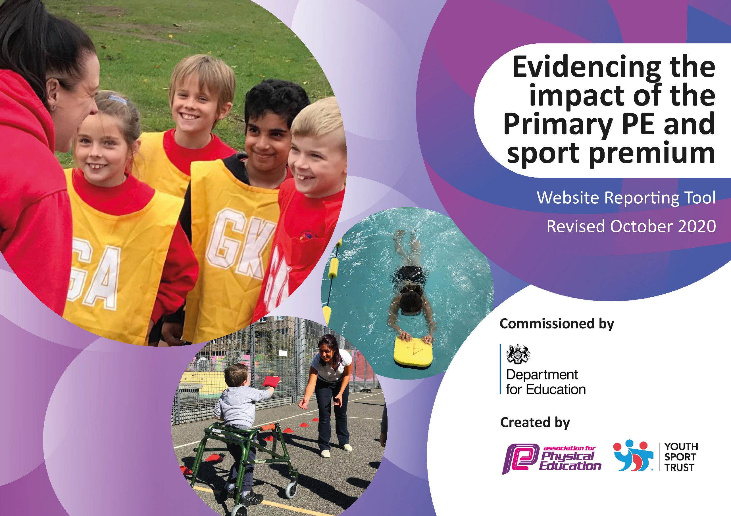
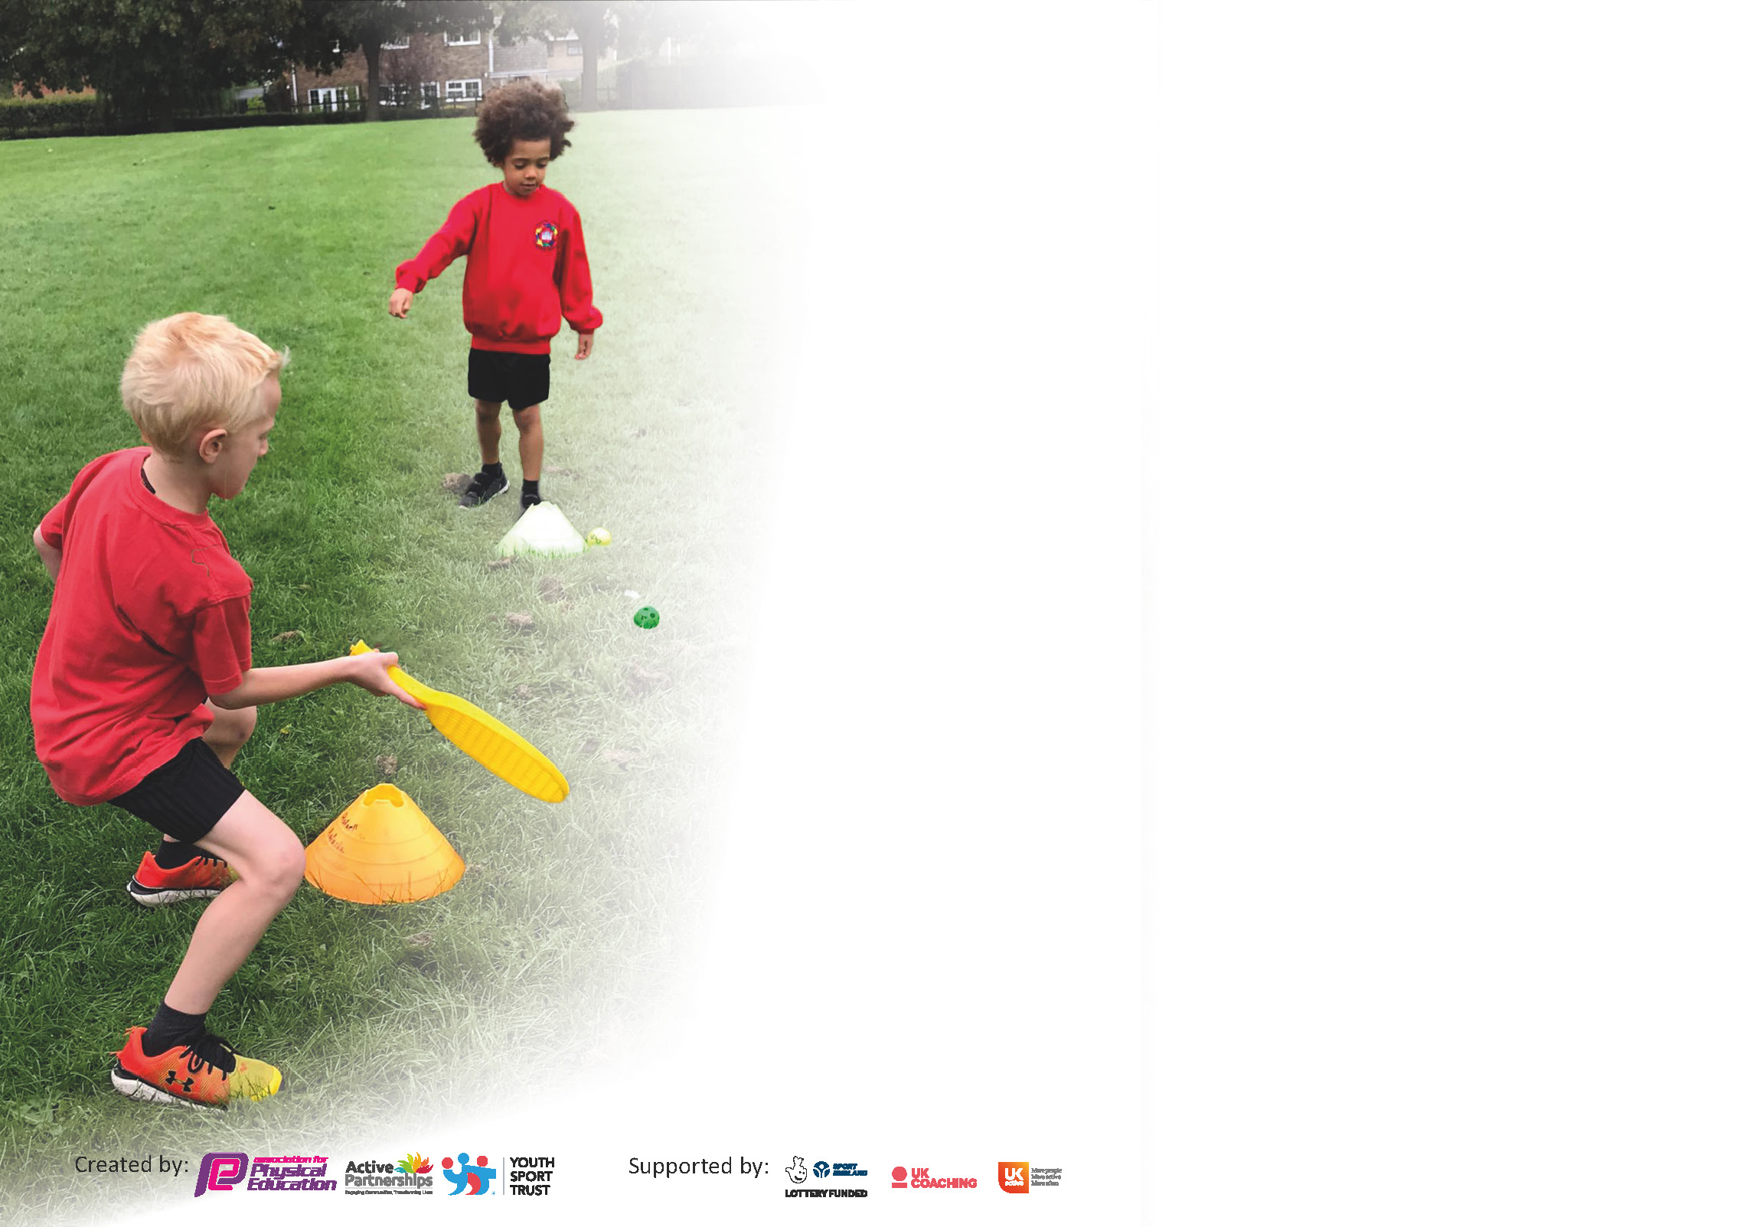

It is important that your grant is used effectively and based on school need. The Education Inspection Framework (Ofsted 2019 p64) makes clear there will be a focus on ‘whether leaders and those responsible for governors all understand their respective roles and perform these in a way that enhances the effectiveness of the school’.

Under the Quality of Education criteria (p41) inspectors consider the extent to which schools can articulate their curriculum (INTENT), construct their curriculum (IMPLEMENTATION) and demonstrate the outcomes which result (IMPACT).

To assist schools with common transferable language this template has been developed to utilise the same three headings which should make your plans easily transferable between working documents.

Schools must use the funding to make additional and sustainable improvements to the quality of Physical Education, School Sport and Physical Activity (PESSPA) they offer. This means that you should use
the Primary PE and sport premium to:

- Develop or add to the PESSPA activities that your school already offer
- Build capacity and capability within the school to ensure that improvements made now will benefit pupils joining the school in future years

Please visit gov.uk for the revised DfE guidance including the 5 key indicators across which schools should demonstrate an improvement. This document will help you to review your
provision and to report your spend. DfE encourages schools to use this template as an effective way of meeting the reporting requirements of the Primary PE and sport premium.

We recommend you start by reflecting on the impact of current provision and reviewing the previous spend.

Schools are required to publish details of how they spend this funding as well as on the impact it has on pupils’ PE and sport participation and attainment by the end of the summer term or by 31st July 2021 at the latest.

** In the case of any under-spend from 2019/20 which has been carried over this must be used and published by 31st March 2021.

We recommend regularly updating the table and publishing it on your website throughout the year. This evidences your ongoing self-evaluation of how you are using the funding to secure maximum, sustainable impact. Final copy must
be posted on your website by the end of the academic year and no later than the 31st July 2021. To see an example of how to complete the table please click HERE.
Created by: Supported by:

Spa Academy Askern - Impact Report for the Primary PE and Sport Pupil Premium September 2020 – July 2021
Support for review and reflection - considering the 5 key indicators from DfE, what development needs are a priority for your setting and your pupils now and why? Use the space below to reflect on previous spend and key achievements and areas for development.

Please note: Although there has been considerable disruption in 2020 it is important that you publish details on your website of how you spend the funding - this is a legal requirement.

N.B. In this section you should refer to any adjustments you might have made due to Covid-19 and how these will influence further improvement.
Key achievements to date until July 2020: | Areas for further improvement and baseline evidence of need:
- Swimming provision in Year 5 for the majority of the cohort despite COVID19  - Involvement in family of school’s competitions up until March 2020  - After School Club and Lunchtime Clubs ran by sports coach and Aspire lead in school  - Staff CPD through specialist coaching and team teaching  - PE Leader attends PE network  - Transition work through sporting activities with secondary practitioners  - PE Kit policy implemented and provided where pupils do not have appropriate kit. | - Improved playground activities led by sports leaders and ran by Teaching Assistants rather than MDSAs  - Improved extra-curricular offer  - Clear curriculum intent for PE and Sport  - Curriculum map to be improved to provide a range of broad and balanced activities  - Staff audit on PE skills  - Assessment procedures in place and utilized by all staff  - Participation in charity related sports activities (Campsmount support)  - Skip2Bfit resources embedded within the school day

Meeting national curriculum requirements for swimming and water safety.
What percentage of your current Year 6 cohort swim competently, confidently and proficiently over a distance of at least 25 metres?  N.B. Even though your pupils may swim in another year please report on their attainment on leaving  primary school at the end of the summer term 2020. | 88%
What percentage of your current Year 6 cohort use a range of strokes effectively [for example, front crawl, backstroke and breaststroke]? | 88%
What percentage of your current Year 6 cohort perform safe self-rescue in different water-based situations? | 81%
Schools can choose to use the Primary PE and Sport Premium to provide additional provision for swimming but this must be for activity over and above the national curriculum requirements. Have you used it in this way? | Yes/No

Did you carry forward an underspend from 2019-20 academic year into the current academic year? YES/NO * Delete as applicable

If YES you must complete the following section
If NO, the following section is not applicable to you

If any funding from the academic year 2019/20 has been carried over you MUST complete the following section. Any carried over funding MUST be spent by 31 March 2021.
Academic Year: September 2020 to March 2021 | Total fund carried over: £3400 | Date Updated: Sept 2020
What Key indicator(s) are you going to focus on?  Engagement in sport and physical activity and increased awareness of Healthy lifestyles and eating. |  |  |  | Total Carry Over Funding:
 |  |  |  | £3400
Intent | Implementation |  | Impact
Your school focus should be clear how you want to impact on your pupils.  Community Day – linked to Healthy Living, Eating and Lifestyles  Additional sport experiences on offer to each year group, some of which will be funded through expect youth as part of schools involvement in OA25  - Xscape Gravity – Y3  - Hatfield Outdoor Centre – Y4  - Go Ape Leeds – Y5  - Ski Experience – Y6 | Make sure your actions to achieve are linked to your intentions:  Matt Gelsthorpe to run Healthy Lifestyle activities and workshops to educate all pupils but with a particular focus on targeted pupils.  Introduce new sports and activities | Carry over funding allocated:  £900 – resources and release time  £2500 | Evidence of impact: How can you measure the impact on your pupils; you may have focussed on the difference that PE, SS & PA have made to pupils re-engagement with school. What has changed?:  Improved physical, mental and social skills. Family engagement and embedding healthy lifestyles.  Pupil interest and engagement in new activities showing resilience and risk taking. | Sustainability and suggested next steps and how does this link with the key indicators on which you are focussing this academic year?:  Yearly events and engagement with other partners.  Sports embedded in curriculum map

Action Plan and Budget Tracking
Capture your intended annual spend against the 5 key indicators. Clarify the success criteria and evidence of impact that you intend to measure to evaluate for pupils today and for the future.

Academic Year: 2020/21 | Total fund allocated: £18,490 | Date Updated: July 2021
Key indicator 1: The engagement of all pupils in regular physical activity – Chief Medical Officers guidelines recommend that primary school pupils undertake at least 30 minutes of physical activity a day in school |  |  |  | Percentage of total allocation:
 |  |  |  | (£10,500) 56.8%
Intent | Implementation |  | Impact
Your school focus should be clear what you want the pupils to know and be able to do and about what they need to learn and to consolidate through practice: | Make sure your actions to achieve are linked to your intentions: | Funding allocated: | Evidence of impact: what do pupils now know and what can they now do? What has changed?: | Sustainability and suggested next steps:
Daily physical activities utilized across the school at break times and lunchtimes | Physical activity promoted with all pupils as well as specifically targeted pupils | CPD for staff £100  Staff Costs  £8000 | Physical activity embedded into the school day | Expected attainment across year groups after a year in place
Extra Curricular offer improved for all pupils | Increased offer within the school day and after school to appeal to a wider range of pupils | Campsmount Sports Coaches £2000.  Other coaches £500 | Increase of over 20% taking part in extra curricular activities | Involvement of staff in additional activities out of school hours
Key indicator 2: The profile of PESSPA being raised across the school as a tool for whole school improvement |  |  |  | Percentage of total allocation:
 |  |  |  | (£500) 2.7%
Intent | Implementation |  | Impact
Your school focus should be clear what you want the pupils to know and be able to do and about what they need to learn and to consolidate through practice: | Make sure your actions to achieve are linked to your intentions: | Funding allocated: | Evidence of impact: what do pupils now know and what can they now do? What has changed?: | Sustainability and suggested next steps:
Sports Leaders | Lead lunchtime and breaktime activities for younger pupils and support lunchtime supervisors | Sports Leader to embed in Autumn term £100 | Sense of responsibility, organization and leadership skills. Role models for younger students. Reduction in behavioral issues ay social times | Indoor and outdoor activities for leaders to organize in future.
Attendance at Pyramid Schools Competitions and school sports days | Pupils provided with different experiences and opportunities to work as part of a team and compete against others, respect rules and other adults. | £500 Buses and staff cover (see above) and trophies/rewards | Improved physical, mental and social skills. | Club links to competitions embedded in after

Key indicator 3: Increased confidence, knowledge and skills of all staff in teaching PE and sport |  |  |  | Percentage of total allocation:
 |  |  |  | (£3000) 16.2%
Intent | Implementation |  | Impact
Your school focus should be clear | Make sure your actions to | Funding | Evidence of impact: what do | Sustainability and suggested
what you want the pupils to know | achieve are linked to your | allocated: | pupils now know and what | next steps:
and be able to do and about | intentions: |  | can they now do? What has
what they need to learn and to |  |  | changed?:
consolidate through practice:
Staff to team teach alongside sports specialists | Key staff to receive support for at least half a term of the academic year in an activity of weakness | £3000 coaches from Campsmount (part of total costs) | Improved engagement and participation. Increased staff confidence in delivery. | Roll out to other sport provision
Transition work for Y6 pupils. | Y6 staff and pupils to receive training and experiences of a range of secondary school sports. | See above | Improved engagement and participation. Increased staff confidence in delivery. | Y6 engagement ready for transition to secondary.
Key indicator 4: Broader experience of a range of sports and activities offered to all pupils |  |  |  | Percentage of total allocation:
 |  |  |  | (£2490) 13.5%
Intent | Implementation |  | Impact
Your school focus should be clear | Make sure your actions to | Funding | Evidence of impact: what do | Sustainability and suggested
what you want the pupils to know | achieve are linked to your | allocated: | pupils now know and what | next steps:
and be able to do and about | intentions: |  | can they now do? What has
what they need to learn and to |  |  | changed?:
consolidate through practice:
Additional sport experiences on offer to each year group, some of which will be funded through expect youth as part of schools involvement in OA25  - Xscape Gravity – Y3  - Hatfield Outdoor Centre – Y4  - Go Ape Leeds – Y5  - Ski Experience – Y6 | Introduce new sports and activities | £2500 | Pupil interest and engagement in new activities showing resilience and risk taking. | Sports embedded

Key indicator 5: Increased participation in competitive sport |  |  |  | Percentage of total allocation:
 |  |  |  | (£2000) 10.8%
Intent | Implementation |  | Impact
Your school focus should be clear | Make sure your actions to | Funding | Evidence of impact: what do | Sustainability and suggested
what you want the pupils to know | achieve are linked to your | allocated: | pupils now know and what | next steps:
and be able to do and about | intentions: |  | can they now do? What has
what they need to learn and to |  |  | changed?:
consolidate through practice:
Competitive schools tournaments | Increased numbers of pupils taking part in seasonal competitive sports through Family of schools links and in-school competitions | Transport costs and staff release  £2000 coaches from Campsmount (part of total costs) | Improved physical, mental and social skills. | Clubs embedded in offer within school to support competitions

Signed off by
Head Teacher: | Emma Anderson
Date: | 18.07.21
Subject Leader: | Matthew Gelsthorpe
Date: | 18.07.21
Governor: | Babs Lynds
Date: | 18.07.21

